Interpret a Data Visualization on LinkedIn Top Skills

*Submitted by,*

Name: Sagar Patil

Email: [spatilscience@gmail.com](mailto:spatilscience@gmail.com)

**1. Which are top 3 skills globally in demand for year 2016?**

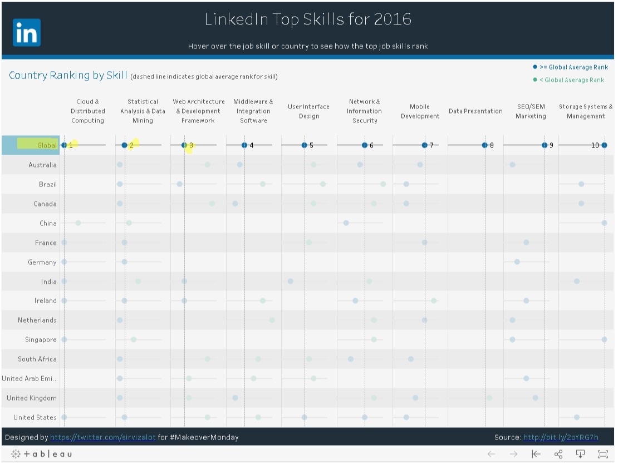

From the dashboard after clicking global we can see that the top three skills in demand are:

1. Cloud & Distributed Computing
2. Statistical Analysis & Data Mining
3. Architecture & Development Framework

**2. How skills demand in India compare to global skills demand for year 2016?**

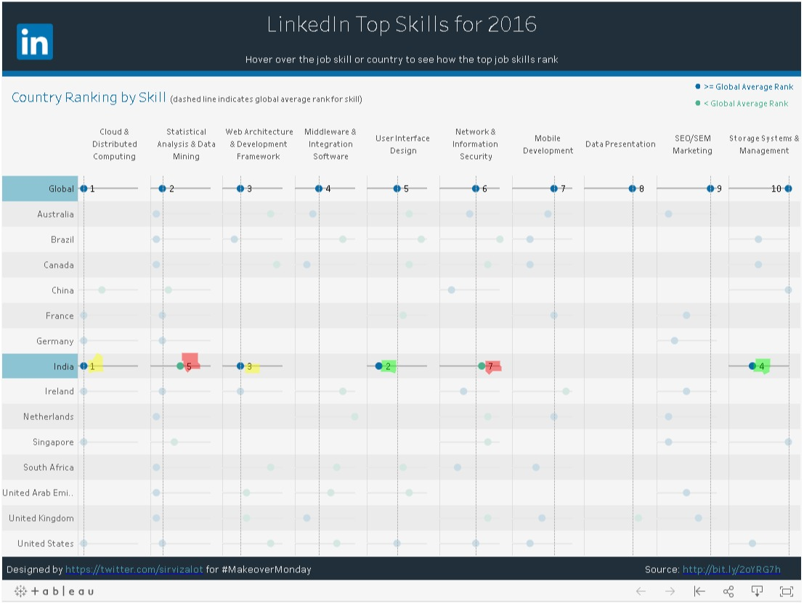

For comparing India’s skill demand with global skills demand from that dashboard, I clicked on Global and India, this showed ranking for global as well as India for skills demand. By comparing we can see that

1. India matches demand with global average in Cloud & Distributed Computing, Web Architecture & Development Framework.
2. India has more demand than global average in User Interface Design, Storage systems and management.
3. India has less demand than global average in Statistical Analysis & Data Mining, Network & Information Security.

**3. Which are countries having more demand than global average for statistical analysis and data mining for year 2016?**

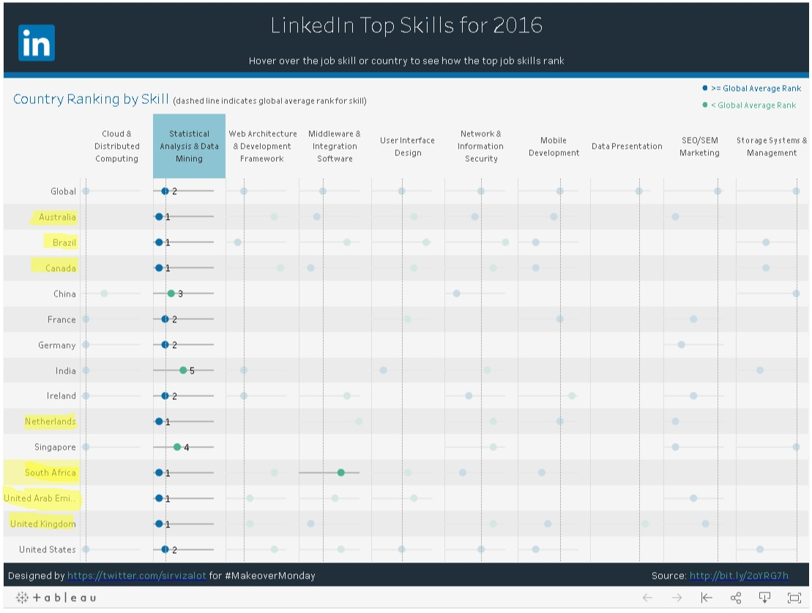

Countries which has more demand than the global average demand for skill Statistical Analysis & Data Mining are: Australia, Brazil, Canada, Netherlands, South Africa, United Arab Emirates, United Kingdom.

We can also see that Countries matching the global average demand for Skill Statistical Analysis & Data Mining are: France, Germany, Ireland, United states.

Additionally, Countries having less demand than the global average demand for Skill Statistical Analysis & Data Mining are: China, India, Singapore.